**VAN SALE**

**Application settings->Application features->multistore->update**

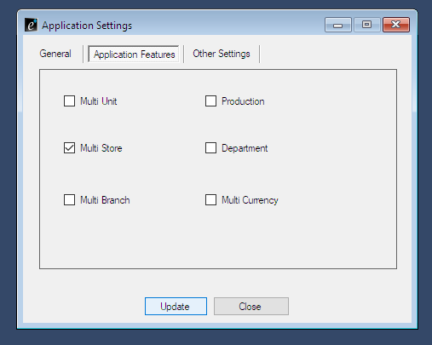

**Create stores**

**Master->store->create store names**

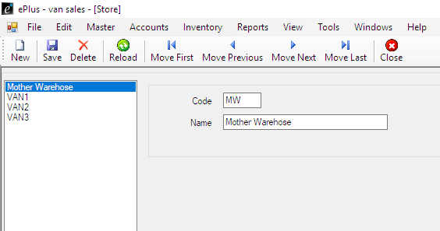

**Purchase items for Mother warehouse**

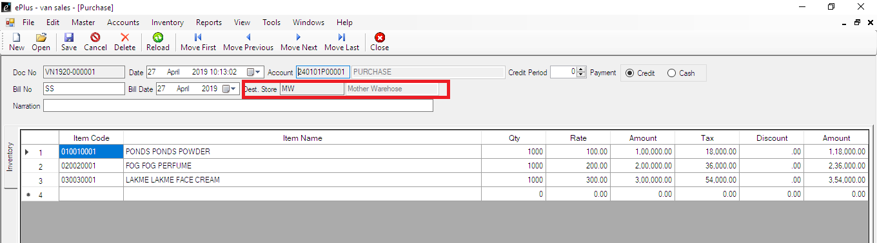

**Activate stock transfer in and stock transfer out**

**Tools->settings->function settings->Material Transfer->Activate stock transfer in and out**

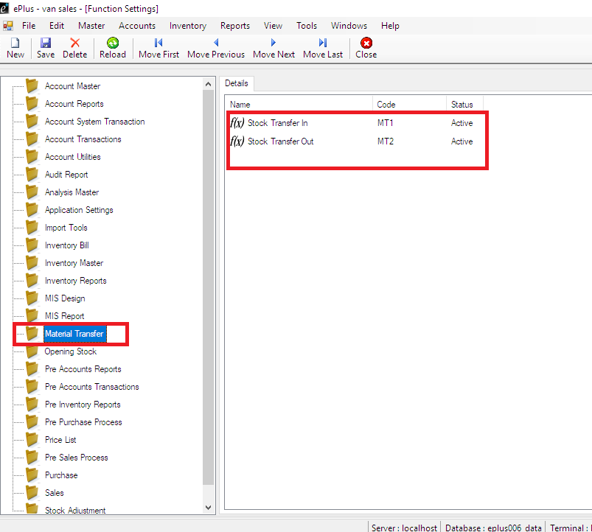

**Give privillage for Material Transfer**

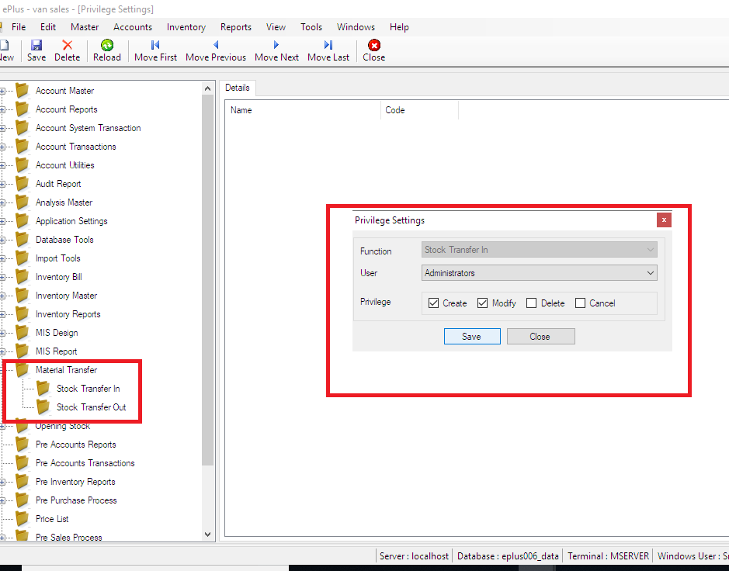

**Stock Transfer out**

**Inventory->stock transfer out->select**

**Select source store in MW**

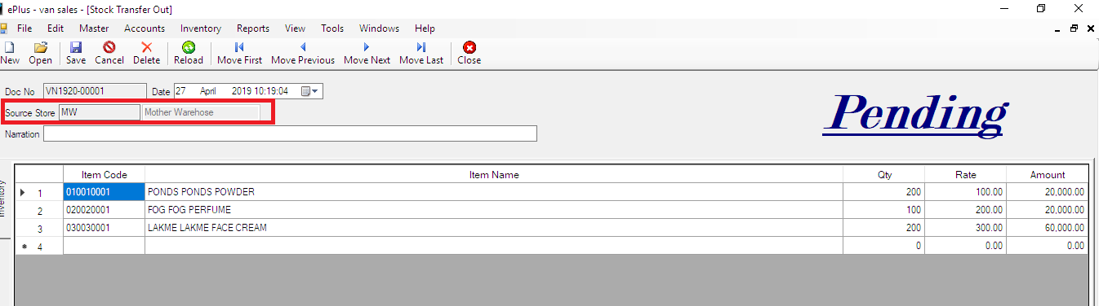

**Call function Activate**

**Tools->function settings->material transfer->stock transfer in->right click->Edit->other->call function activate**

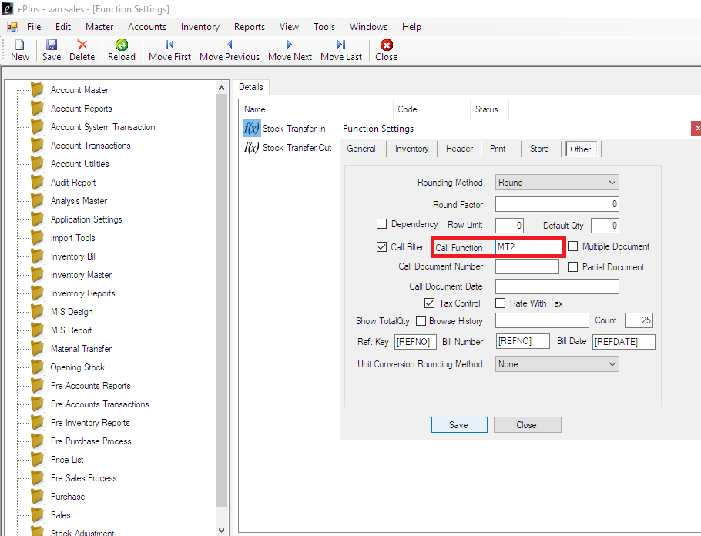

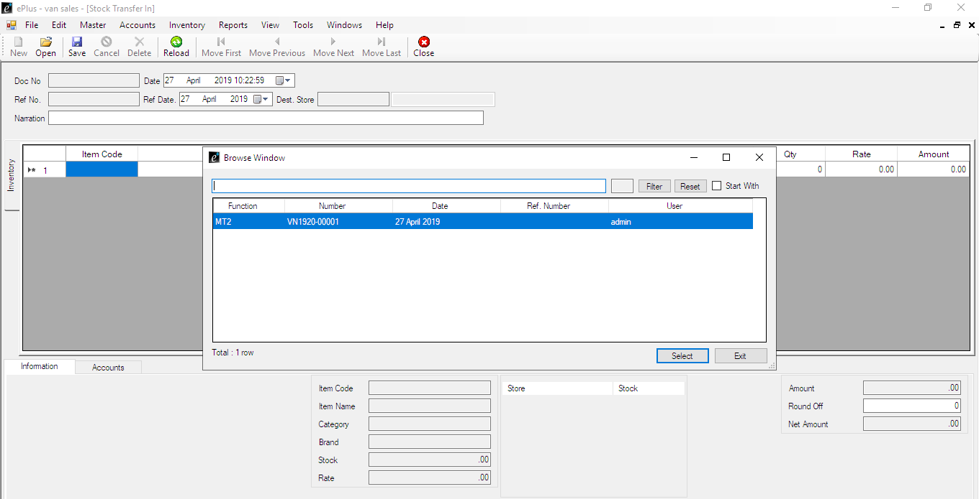

**Please update this query.to get store in stock transfer in**

**UPDATE `functioninvdetails` SET `STRDST`='Branch' WHERE `CODE`='MT1';**

**UPDATE `functioninvdetails` SET `STRSRC`='Branch' WHERE `CODE`='MT2';**

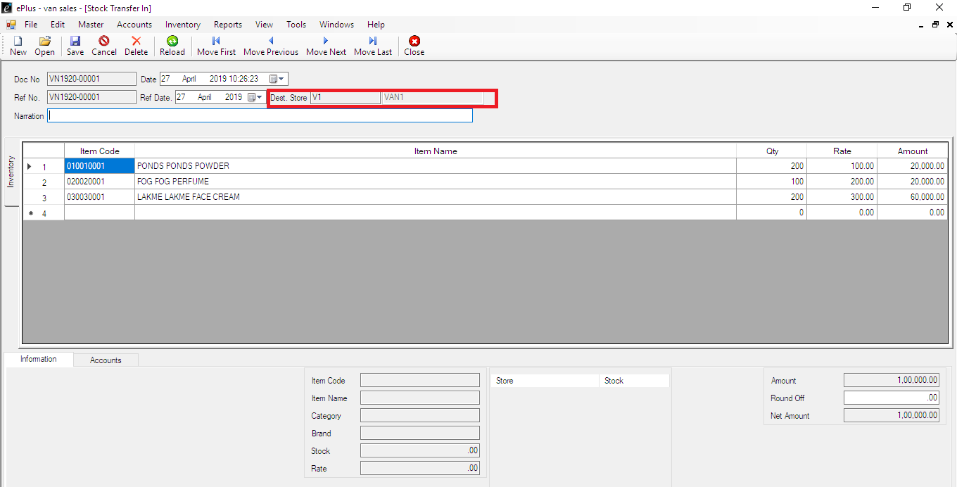

**SALE**

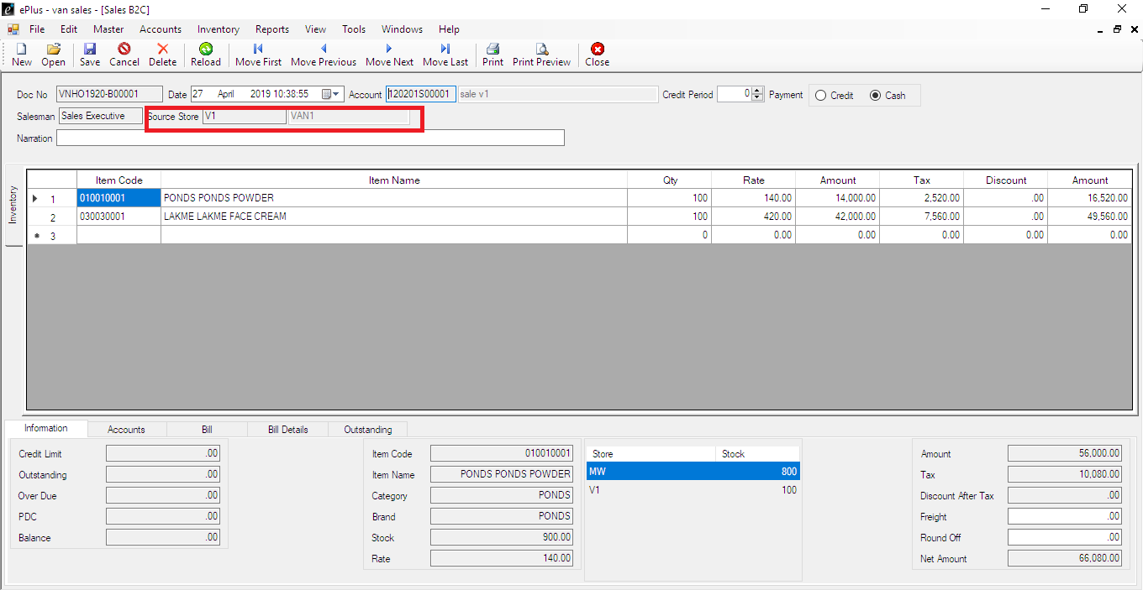

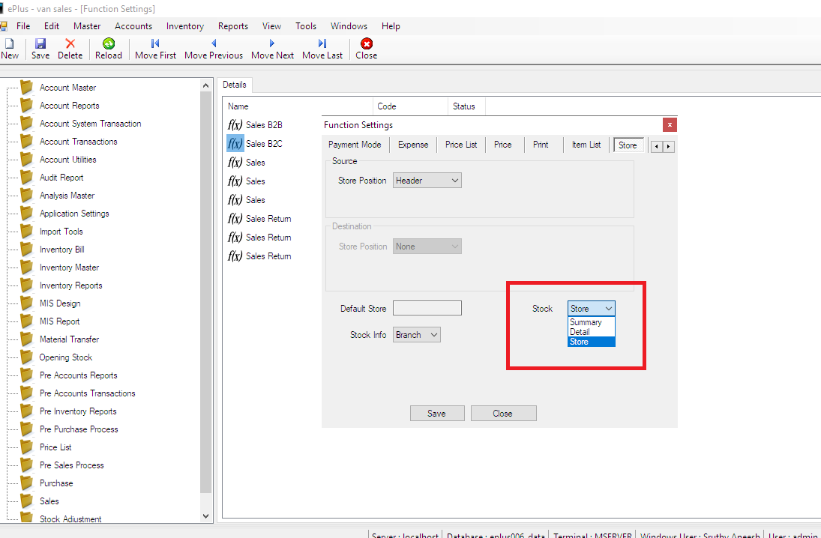

**REPORTS**

**To Get Transfer Details**

**Reports->material Transfer**

**Material Transfer**

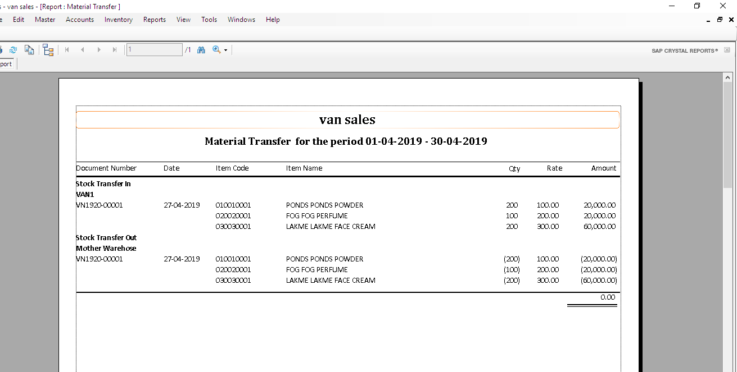

**Balance stock Report**

**Reports->stock Report->store**

